## ****Data Abstraction****

1. It hides unnecessary code details from the user.
2. Also, when we do not want to give out sensitive parts of our code implementation and this is where data abstraction came.
3. Abstraction is used to hide the internal functionality of the function from the users.
4. The users only interact with the basic implementation of the function, but inner working is hidden.
5. User is familiar with that ****"what function does"**** but they don't know ****"how it does’.****
6. A method becomes abstract when decorated with the keyword @abstractmethod.
7. An Abstract class can contain the both method normal and abstract method.
8. An Abstract cannot be instantiated; we cannot create objects for the abstract class.

**# Python program showing abstract base class work**

from abc import ABC, abstractmethod

class Polygon(ABC):

@abstractmethod

def noofsides(self):

pass

class Triangle(Polygon):

# overriding abstract method

def noofsides(self):

print("I have 3 sides")

class Pentagon(Polygon):

# overriding abstract method

def noofsides(self):

print("I have 5 sides")

class Hexagon(Polygon):

# overriding abstract method

def noofsides(self):

print("I have 6 sides")

class Quadrilateral(Polygon):

# overriding abstract method

def noofsides(self):

print("I have 4 sides")

# Driver code

R = Triangle()

R.noofsides()

K = Quadrilateral()

K.noofsides()

R = Pentagon()

R.noofsides()

K = Hexagon()

K.noofsides()

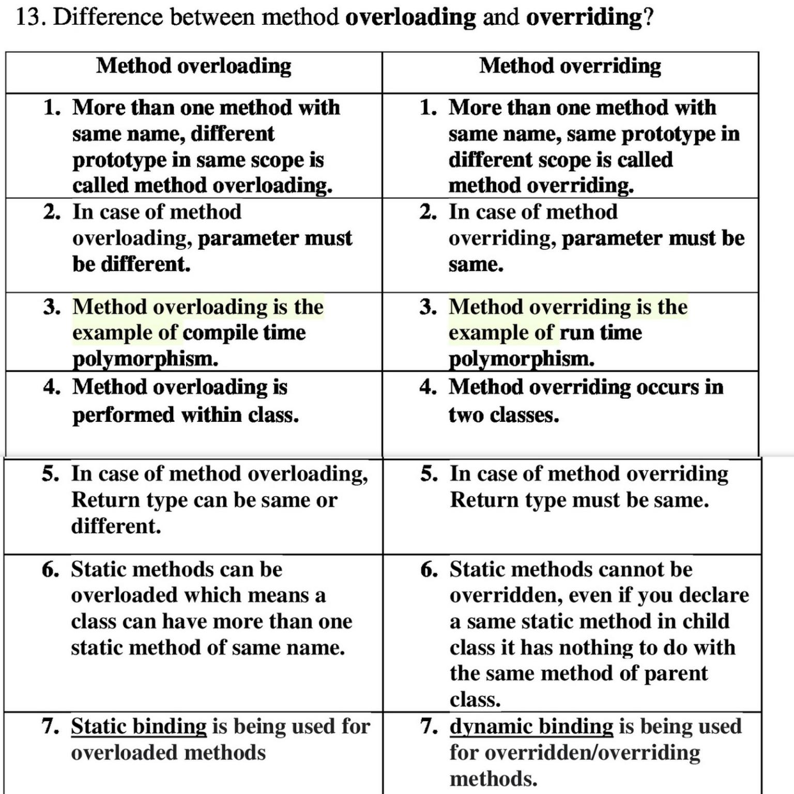

**Programming Exercise**

1. Write a Python program to create a class representing a Circle. Include methods to calculate its area and perimeter.
2. Write a Python program to create a person class. Include attributes like name, country and date of birth. Implement a method to determine the person's age.
3. Write a Python program to create a calculator class. Include methods for basic arithmetic operations.
4. Write a Python program to create a class that represents a shape. Include methods to calculate its area and perimeter. Implement subclasses for different shapes like circle, triangle, and square.
5. Write a Python program to create a class representing a shopping cart. Include methods for adding and removing items, and calculating the total price.
6. Write a Python program to create a class representing a bank. Include methods for managing customer accounts and transactions.

**OOP related programming exercise**

https://www.w3resource.com/python-exercises/oop/index.php